

REPUBLIC OF CAMEROON

Peace-Work-Fatherland

MINISTER OF HIGHER EDUCATION

FACULTY OF ENGINEERING AND TECHNOLOGY

REPUBLIQUE DU CAMEROUN

Paix-Travail-Patrie

MINISRE DE L’ENSEIGNEMENT SUPERIEURE

FACULTE D’ENGENIERE ET DE TECHNOLOGIE

**Instructor: DR NKEMENI VALERY**

**DEPARMENT OF COMPUTER ENGINEERING**

**COURSE** **TITLE**: Internet and Mobile Programming

PROGRAMMING

**GROUP TWO**

|  |  |
| --- | --- |
| **Names Matricule** | |
| **ETOH KIERA EKUTY** | **FE20A035** |
| **GWANA JUSLINE AKAH** | **FE20A047** |
| **LASSI FOKOU BERICE JILDO** | **FE20A054** |
| **YUVEN BRIAN** | **FE20A125** |
| **AJONG NTI MAGCELOUS** | **FE20A006** |
|  |  |

**Design and implementation of Market management system**

**Task #2**

1. **Introduction**

1.1. **Purpose**

The purpose of this Software Requirements Specification (SRS) is to define the functional and non-functional requirements for the Design and implementation of Market Management System (MMS).

1.2. **Scope**

MMS is a mobile application that allows users (buyers and sellers) to view available products in the market and their respective prices, availability, and location. The application also allows sellers to upload their products and their respective prices, availability, and location.

1.3. **Overview**

MMS is an online application, which provides a platform for buyers and sellers to interact. Buyers can view available products in the market and their respective prices, availability, and location. Sellers can upload their products and their respective prices, availability, and location. The application also provides a search feature to help buyers find what they are looking for.

2. **Requirements**

2.1. **Functional Requirements**

2.1.1. **Login/Registration**

- Users should be able to register for an account and login using the credentials provided.

- Users should be able to reset their passwords if they forget it.

- Users should be able to logout of their accounts.

2.1.2. **Product Search**

- Users should be able to search for products in the market using keywords.

- Users should be able to filter search results by price range, availability, and location.

2.1.3. **Product Listing**

- Sellers should be able to list their products in the application.

- Sellers should be able to provide information about their products such as prices, availability, and location.

2.1.4 **User Dashboard Setup**

- Each user should have a profile where they can manage their information and view their activities on the system

2.1.5 **Review and Rating System**

- The system should have a review and rating system to allow buyers to rate and review products and sellers based on their experience.

2.2. **Non-Functional Requirements**

2.2.1. **Security**

- The application should use secure protocols for all communication.

- All user data should be encrypted and stored securely.

2.2.2. **Performance**

- The application should be able to handle large numbers of concurrent users.

- The application should have a response time of less than 2 seconds.

2.2.3. **User Interface**

- The application should have an intuitive and user-friendly interface.

- The application should be accessible on both desktop and mobile devices.

2.2.4. **Support**

- The application should provide support for multiple languages.

2.2.5 **Reliability**: The system must ensure that buyers and sellers' data is accurate and reliable.

2.2.6 **Availability**: The system must be available 24/7 to enable users to access it any time they want.

3. **Dependencies**

- The application will require an internet connection for use.

4. **User Documentation**

4.1**. Technical Support**

- The application should provide technical support for users who encounter problems with the application.

- The technical support team should be available 24/7

5. **Acceptance Criteria**

- The application should meet all of the requirements specified in this SRS(software requirement specification).

- The application should be tested thoroughly before being released to the public.

**Task #3**

**Analysis Of The Requirement Specifications**

**Introduction**

This document outlines the development plan for “MMS”, a mobile app that will allow customers to browse and view goods by their location in the market and price from different vendors. The intended readership of the plan are the developers and the instructor of the project.

**Overall Description**

In this age and time, users are constantly seeking convenient ways to shop in the market without the stress moving around the entire market looking for what they want. However, with so many brands and products available in a particular market, it can be overwhelming for customers to find what they want. “MMS” aims to solve this problem by offering a platform where

- The buyers are aware of the availability, prices, and location of their desired item before they visit the market

- The sellers can attract the right customers to their shades

**Customers**

They are likely to be tech-savvy and confortable using web apps

* Sellers in the Market
* Buyers

**Functionalities**

* Users should be able to create an account with email, password, full name and user name,
* Users should be able to browse and search for Product base on keywords and category,
* Users should be able to view Product details, such as descriptions, images, location, price and reviews.
* Sellers should be able to add products to their shop,
* Sellers should be able to set their Dashboard, profile description and upload a profile picture

**Platform**

The framework is Django for backend,

The framework is Bootstrap for frontend

The main IDE for the frontend development is visual studio code

The hosting environment for development is Local host since it is cheaper and buying a domain name is much expensive

The software use for modelling is ER-Builder and Modelio

The development of this app will follow the agile model for these reasons:

* Increase in Software Quality
* Agile models breaks down the project into multiple, manageable units
* Can help the development team to quickly respond to changes in customer requirement
* Promote frequent testing and integration of new features, which is essential for a MMS
* Allow faster and more efficient development, which is a successful launch of a MMS
* User-Focused Process

**Hardware requirement**

* RAM : at least 4 Gb
* Memory : at 15 Gb

**User Class and Characteristics**

There will be three types of users for “MMS”: Sellers, Buyers and an admin. Sellers will be able to use all the app’s features, while admins will have access to additional features such as managing product listings, Review of seller’s product and Authentication

**System Features and Requirements**

* **Functional Requirements**
* Users should be able to create an account with email, password, full names and user name,
* Users should be able to browse and search for products based on keywords and category,
* Users should be able to view product details, such as descriptions, images, location, price and reviews.
* Sellers should be able to add products to their shop ,
* Sellers should be able to set their dashboard, profile description and upload a profile

**Programming Languages**

* Back-end Technology: Python
* Database Management system : MYSQL
* Front-end Technology: HTML, CSS and JavaScript

**Non-functional requirements**

**Performance Requirements**

* The app should load fast.
* The app should react to user interaction fast.
* Optimized database to ensure fast query performance.

**Software Quality Attributes**

* **Availability:** The app should have a goal of 99.9% availability to ensure Users can access anytime.
* **Correctness:** The app should accurately display product information.
* **Maintainability:** The app should be continuously integrated so that features, updates, and bug fixes can be deployed rapidly without downtime.
* **Usability:** The interface should be intuitive and easy to navigate, allowing sellers to list and add products to their store and buyers to browse through without confusion.

**Use cases**

**Use case diagram**

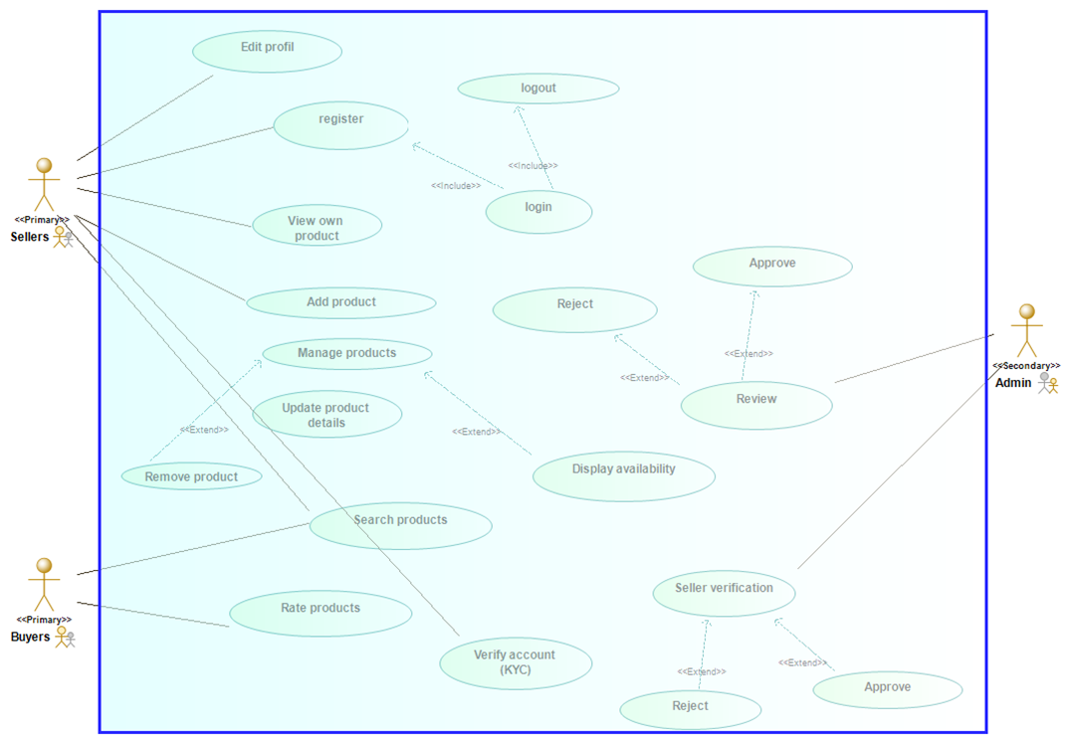

**Market Management System**

**Textual Description of Use cases**

* Use case: Registration

Actor: Seller, Admin

Description: Seller and admin create accounts by entering their details (email and password)

* Use case: Login/Logout

Actor: Seller, Admin

Description: Summit email and password as entered during registration to access his account

* Use case: Add products

Actor: Seller

Description: User can add products they have available for sell

* Use case: Manage products

Actor: Seller

Description: User can update product information or remove products if no longer available

* Use case: Search product

Actor: Buyer

Description: The buyer can search products based on categories, price, location and availability

Seller can also search for competitors of same products

* Use case: Rating

Actor: Buyer

Description: Buyer can rate a product based on their customer service and quality of product.

* Use case: KYC verification(Know your customer)

Actor: Seller/ Admin

Description:

* The seller uploads legal documents for verification
* The admin reviews and approves or rejects the uploaded documents of the user
* Use case: Review

Actor: Admin

Description: The admin reviews products uploaded by different sellers depending on the system policy (example, No selling of illegal drugs) and either approves or rejects

**Limitations**

Purchases and payment: Integrating a payment system will be good but it was not integrated for the following reasons

* The buyers can pay for a product , then on reaching the market ,
* The product is out of stocks.
* The quality is not met as seen
* The vendor is not available on reaching the market
* You can find out that the vendor is not real or does not have a physical store.